VRISHANK WARRIER

16014022096

SERVER 1

import socket

ob = socket.socket()

ob.bind(('localhost', 2301))

ob.listen(4)

print("server is ready to listen")

clientobject, add=ob.accept()

print("server is ready to accept the connection")

print("connected with this address: ", add)

ob.close()

CLIENT 1

import socket

ob = socket.socket()

ob.connect(('localhost', 2301))

print("client is ready to accept the connection")

ob.close()

OUTPUT 1

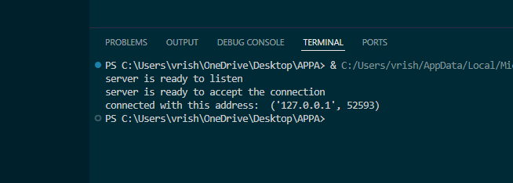

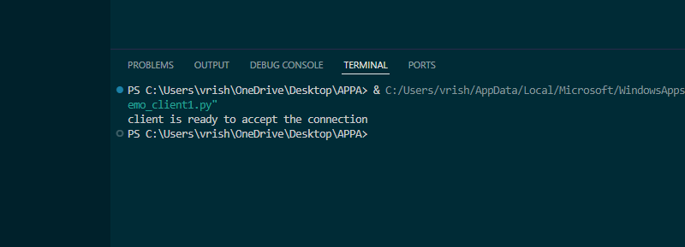

SERVER 2

import socket

ob = socket.socket()

ob.bind(('localhost', 2301))

ob.listen(4)

print("server is ready to listen")

clientobject, add=ob.accept()

print("server is ready to accept the connection")

print("connected with this address: ", add)

gotmsg = clientobject.recv(1024)

gotmsg.decode('utf-8')

print(gotmsg)

ob.close()

CLIENT 2

import socket

ob = socket.socket()

ob.connect(('localhost', 2301))

print("client is ready to accept the connection")

msg = 'hello dazai san here'

ob.send(msg.encode('utf-8'))

ob.close()

OUTPUT 2

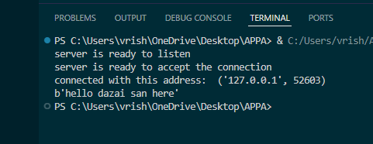

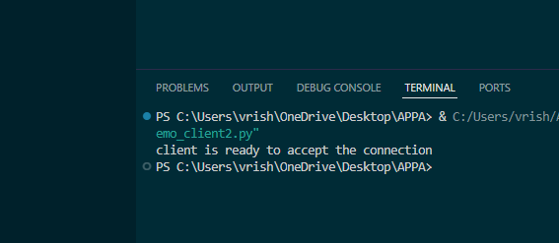

SERVER 3

import socket

ob = socket.socket()

ob.bind(('localhost', 2301))

ob.listen(4)

print("server is ready to listen")

clientobject, add=ob.accept()

print("server is ready to accept the connection")

print("connected with this address: ", add)

conn = True

while conn:

    gotmsg = clientobject.recv(1024)

    gotmsg.decode('utf-8')

    print(gotmsg)

    if len(gotmsg) == 0:

        conn = False

ob.close()

CLIENT 3

import socket

ob = socket.socket()

ob.connect(('10.0.104.42', 2301))

print("client is ready to send data")

conn = True

while conn:

    msg = input("enter your message: ")

    if msg == 'no':

        conn = False

    else:

        ob.send(msg.encode('utf-8'))

ob.close()

OUTPUT 3

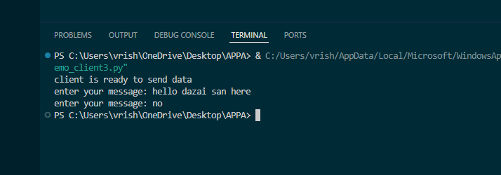

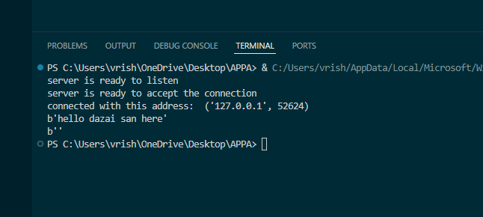

SERVER 4

import socket

host = 'localhost'

port = 1234

server_socket = socket.socket(socket.AF_INET, socket.SOCK_STREAM)

server_socket.bind((host,port))

server_socket.listen(4)

print(**f**"server listening on {host} : {port} ")

client_socket, add = server_socket.accept()

print(**f**"connected by {add}")

while True:

    data = client_socket.recv(1024)

    if not data:

        break

    print(**f**"client :  {data.decode()}")

    msg = input("Server: ")

    client_socket.sendall(msg.encode())

server_socket.close()

client_socket.close()

CLIENT 4

import socket

host = 'localhost'

port = 1234

client_socket = socket.socket(socket.AF_INET,socket.SOCK_STREAM)

client_socket.connect((host, port))

while True:

    message = input("Client: ")

    client_socket.sendall(message.encode())

    data = client_socket.recv(1024)

    print(**f**"Server: {data.decode()}")

    if message.lower() == 'exit' or data.decode().lower() == 'exit':

        break

client_socket.close()

OUTPUT 4

